**Electronic supplementary information**

**efficient in-magnet 15N hyperpolarization  
induced by reversible exchange of  
parahydrogen with AN ir-based catalyst**

D. A. Markelov,\**a,b* A. S. Kiryutin,*a* I. D. Kosenko,*c* Zh. V. Matsulevich,*d*I. A. Godovikov,*c* and A. V. Yurkovskaya*a*

a International Tomography Center, Siberian Branch of the Russian Academy of  
Sciences, ul. Institutskaya 3A, Novosibirsk, 630090 Russia

b Novosibirsk State University, ul. Pirogova 1, Novosibirsk, 630090 Russia

c Nesmeyanov Institute of Organoelement Compounds, Russian Academy of Sciences,  
ul. Vavilova 28, str. 1, Moscow, 119334 Russia

*d Nizhny Novgorod State Technical University,  
ul. Minina 24, Nizhny Novgorod, 603155 Russia*

Catalyst activation

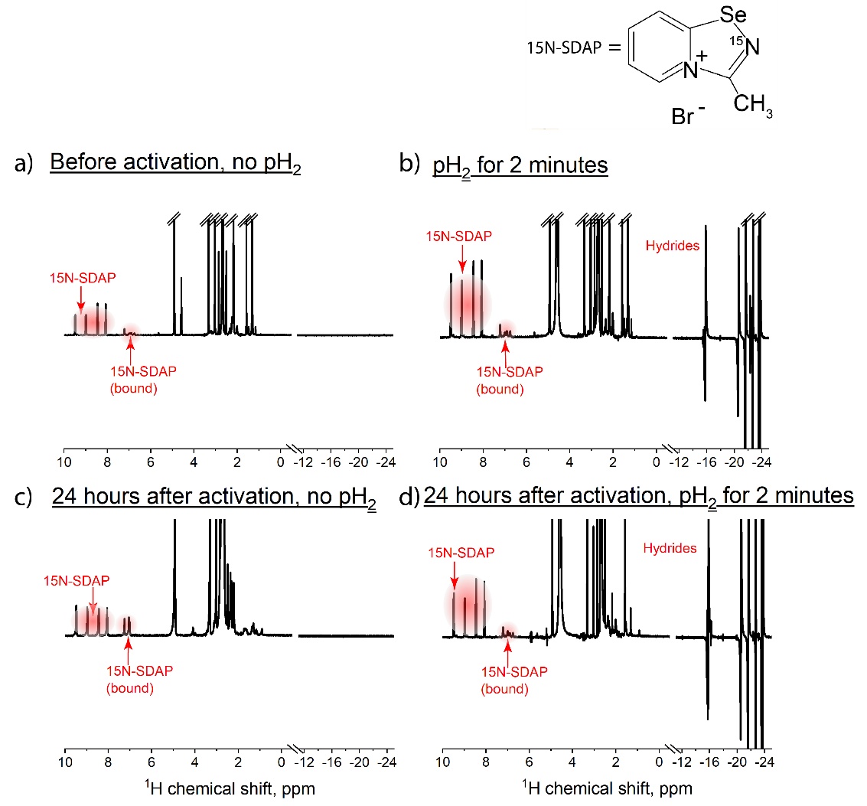

**Figure S1.** 1H NMR spectra of the investigated sample with 15N-SDAP. (**a**) Thermal NMR spectrum before parahydrogen (pH2) bubbling; (**b**) hyperpolarized NMR spectrum acquired with parahydrogen bubbling for 2 min; (**c**) thermal NMR spectrum acquired the next day after the first parahydrogen bubbling; (**d**) hyperpolarized NMR spectrum of the next day pH2-bubbled sample. The temperature of the sample was 15 ° in all cases.

The first step of our experiments was the catalyst activation procedure, during which the active SABRE complexes were formed from [IrCl(COD)(IMes)]. The activation of the catalyst consisted in bubbling the sample containing the pre-catalyst and substrate with parahydrogen. The activation of the catalyst has its own kinetics and steady-state. In the steady-state, the hydride area of 1H NMR spectrum demonstrates stable over time complexes, and subsequent parahydrogen bubbling does not lead to any changes in the 1H NMR spectrum.

Figure S1 demonstrates the 1H NMR spectrum of the investigated sample with 15N-SDAP at different time points. Figure S1a shows the thermal NMR spectrum of the sample before bubbling. The signals from 8 to 10 ppm refer to the aromatic protons of 15N-SDAP, while the signals from 6 to 8 ppm belong to 15N-SDAP in the complex-bound form. The spectral range from 1 to 4 ppm is more complicated and contains the signals from the precatalyst (from COD and IMes) and from the active catalyst. The detailed analysis of these signals for a similar system at different time points can be found, for example, in Ref. [S1]. Figure S1b demonstrates the 1H NMR spectrum obtained after 2 min of the sample bubbling with parahydrogen (catalyst activation). In this case, the hyperpolarized hydrides (from –12 to –25 ppm) are observed, and the subsequent bubbling does not change the NMR spectrum. The hyperpolarization of the hydride 1H nuclei occurs due to the PASSADENA effect [S2].

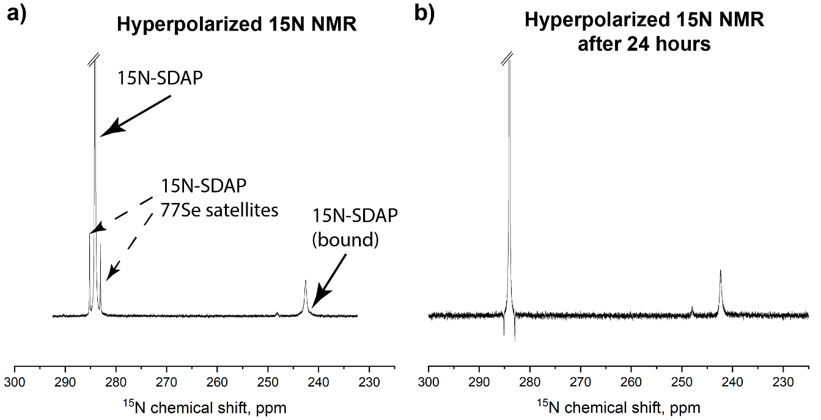

**Figure S2.** Hyperpolarized 15N NMR spectra obtained by SABRE: (**a**) at the first day of the experiments, (**b**) the next day after the experiments.

To demonstrate the stability of the sample and the absence of hydrogenation of 15N-SDAP, we also acquired the 1H NMR spectra in 24 h after the first parahydrogen bubbling of the sample (during these 24 h, we had been conducting the SABRE experiments, and the sample was bubbled with parahydrogen for several hours). Figure 1c shows the thermal 1H NMR spectrum acquired the next day after the first parahydrogen bubbling. No change in the intensity or position of the 1H signals of 15N-SDAP from 8 to 10 ppm is observed. Moreover, parahydrogen bubbling after 24 h leads to the formation of identical hydrides and identical 15N-SDAP signals, as demonstrated in Fig. S1d (compare with Fig. S1b), and no hydrogenation products are observed in the 1H NMR spectrum. The absence of the hydrogenation and stability of the sample can also be alternatively determined in the hyperpolarized 15N NMR spectrum, where no hydrogenation products are observed after 24 h (see Figs. S2a,b). In both cases, the hyperpolarized 15N spectra contain the signals from 15N-SDAP, its 77Se satellites, and 15N-SDAP bound to the Ir-catalyst (it should be noted that the 77Se satellites in these figures have different phases because we used different SABRE protocols for hyperpolarization). The absence of the substrate hydrogenation has also been confirmed in the pioneer SABRE work [S3], where instead of the catalytic hydrogenation of a substrate, it was involved in the reversible interactions with an Ir-catalyst. Such a behavior is typical for a variety of different substrates [S4].

Optimization of the SABRE pulse sequences

The SABRE-INEPT pulse sequence requires an optimization of two time delays between the 1H and 15N pulses, denoted as $τ$ and $τ_{1}$. In our experiments, we used $τ_{1}=10$ ms and optimized time delay $τ$, as demonstrated in Fig. S3. The maximum of the 15N signal enhancement, *ε*, was observed at $τ=8.5$ ms, which we have used in the subsequent experiments with SABRE-INEPT.



**Figure S3.** Dependence of the 15N-SDAP signal enhancement on time delay τ introduced in the SABRE-INEPT pulse sequence (demonstrated in Fig. 1b of the main text). The experimental parameters: τ1 = 10 ms. The experimental data are represented as circles, whereas the theoretically calculated curve for a three-spin system is presented with a solid line.

The DRF-SABRE pulse sequence utilizes two continuous-wave (CW) magnetic fields exciting the nuclear spins of 1H and 15N nuclei in the polarization transfer complex, as demonstrated in Fig. S4. 1H CW field is chosen to be on-resonant to the trans-1H hydride nuclei (trans-position is determined with respect to the complex-bound 15N-SDAP) in the polarization transfer complex. In our case of 15N-SDAP, the resonant position of this proton is equal to –23.72 ppm, which is RF excited, as demonstrated in Fig. S4, left. At the same time, 15N CW field frequency is varied near the resonance of complex-bound 15N-SDAP (242.37 ppm), as shown in Fig. S4, right. The dependence of the 15N signal enhancement *ε* of 15N-SDAP (free) on the frequency of the 15N CW field is demonstrated in Fig. S5. The maximum absolute value of enhancement *ε* is observed at 241.87 ppm frequency of the 15N CW field, which we have used in the subsequent experiments.

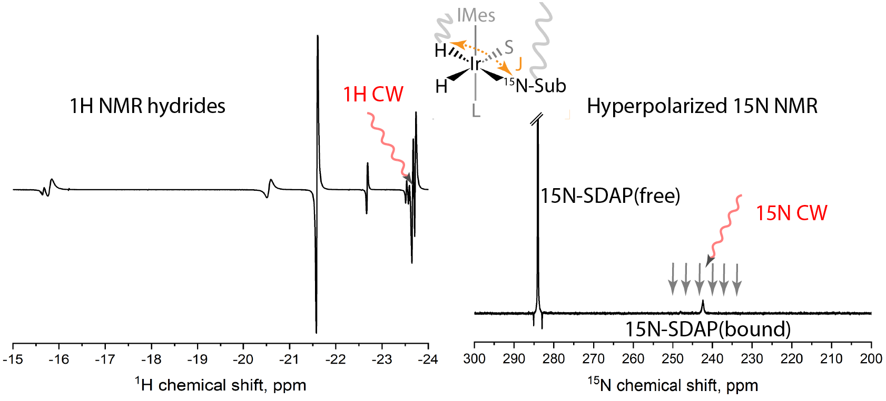

**Figure S4.** Visualization of the 1H and 15N frequencies excited in the DRF-SABRE experiment (demonstrated in Fig.1b, of the main text). (Left) 1H CW is resonant towards hydride 1H nucleus in its trans-position in the complex with respect to 15N-sub. (right) 15N CW frequency is varied near the resonant frequency of complex-bound 15N-SDAP. The optimization of both RF fields leads to the hyperpolarization of 15N-SDAP (free and bound).



**Figure S5.** Dependence of the 15N-SDAP signal enhancement on the 15N CW frequency, $ν_{rf}^{N}$, in the DRF-SABRE experiment. The experimental parameters: the frequency of the 1H CW field was fixed at $ν_{rf}^{H}=-23.72$ ppm. The amplitudes of the CW fields were equal to 8 Hz. The experimental data are represented as circles, whereas the theoretically calculated curve for a three-spin system is a solid line.

**References**

1. A. N. Pravdivtsev, K. L. Ivanov, A. V. Yurkovskaya, P. A. Petrov, H.-H. Limbach, R. Kaptein, H.-M. Vieth, *J. Magn. Reson.*, **2015**, *261*, 73–82. DOI: 10.1016/j.jmr.2015.10.006

2. C. R. Bowers, D. P. Weitekamp, *J. Am. Chem. Soc.*, **1987**, *109*, 5541–5542. DOI: 10.1021/ja00252a049

3. R. W. Adams, J. A. Aguilar, K. D. Atkinson, M. J. Cowley, P. I. P. Elliott, S. B. Duckett, G. G. R. Green, I. G. Khazal, J. López-Serrano, D. C. Williamson, *Science*, **2009**, *323*, 1708–1711. DOI: 10.1126/science.1168877

4. D. A. Barskiy, S. Knecht, A. V. Yurkovskaya, K. L. Ivanov, *Prog. Nucl. Magn. Reson. Spectrosc.*, **2019**, *114–115*, 33–70. DOI: 10.1016/j.pnmrs.2019.05.005